**Analyzing the Data**

**Analysis and Visualization**

* **The data follow a logical pattern without abnormal values as we see the max in rating_numerator is 27 as I eliminated the abnormal values for more valuable results**

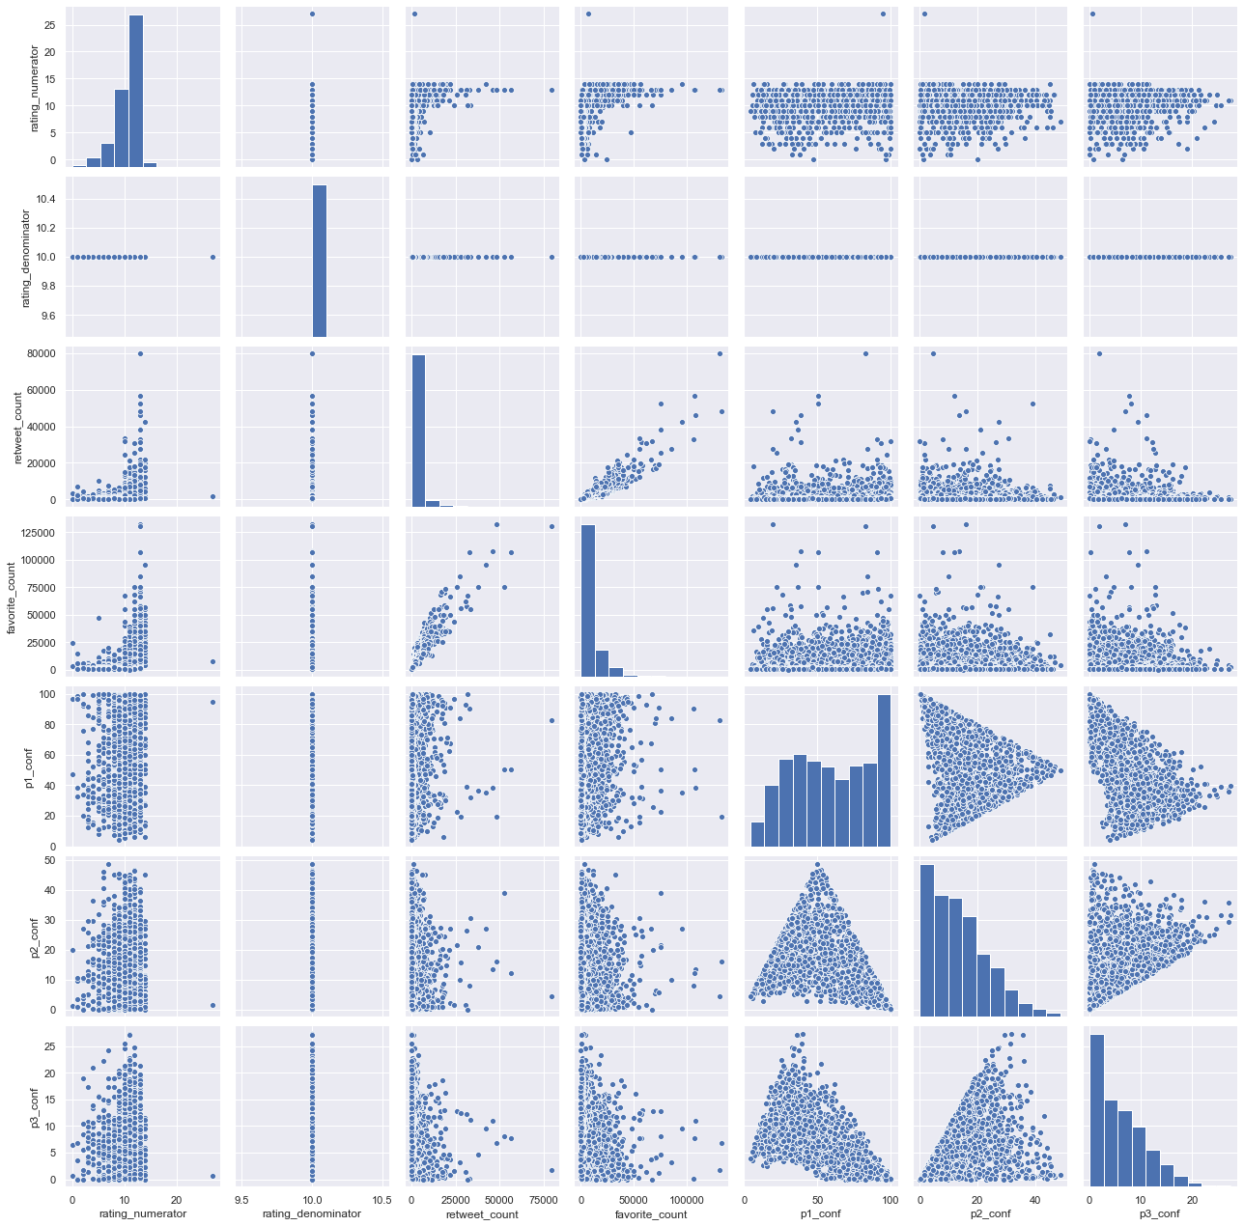

**# track retweet and favorite in time**

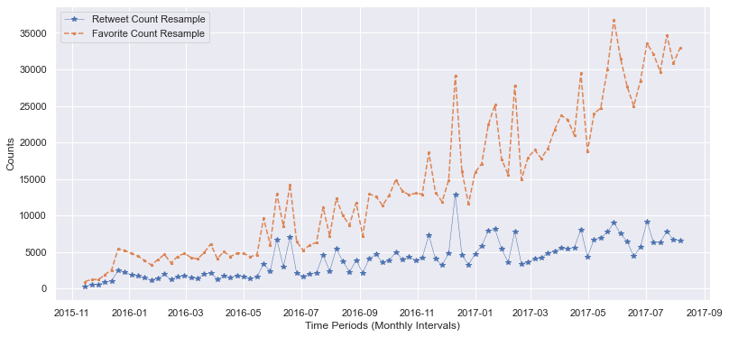

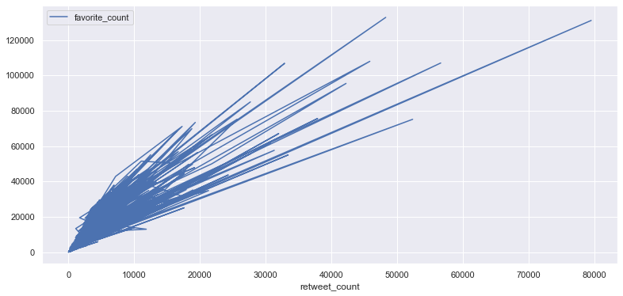

* **this plot shows the interaction with the accounts posts over time by track retweet count and favorite count, as we see, there is an evident upward trend in both retweet and favorite, especially in favorite.**
* **these trends represent that people engagement with the posts is increasing over time which is a great indicator of the quality of content**
* **there is also a clear association between retweet and favorite, as the trend show a Positive relationship**

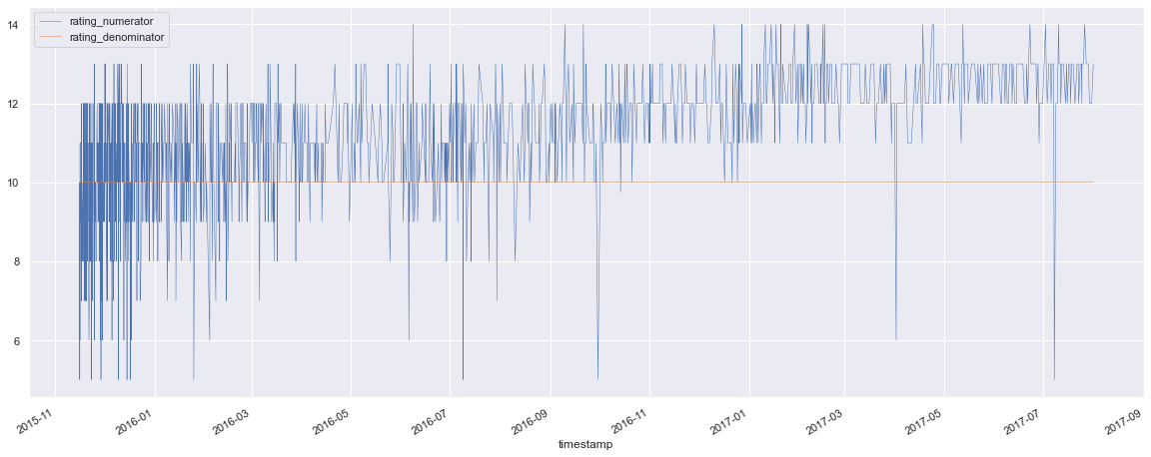

* **As we can see, in the first period, there was a large fluctuation in the evaluation,(from 2015 to march 2016) then it began to stabilize and rise slowly and steadily. Which indicates that the performance rate has increased and the effect of that on the satisfaction rate.**

# **show the comparison between the numbers of the four types by bar plot**

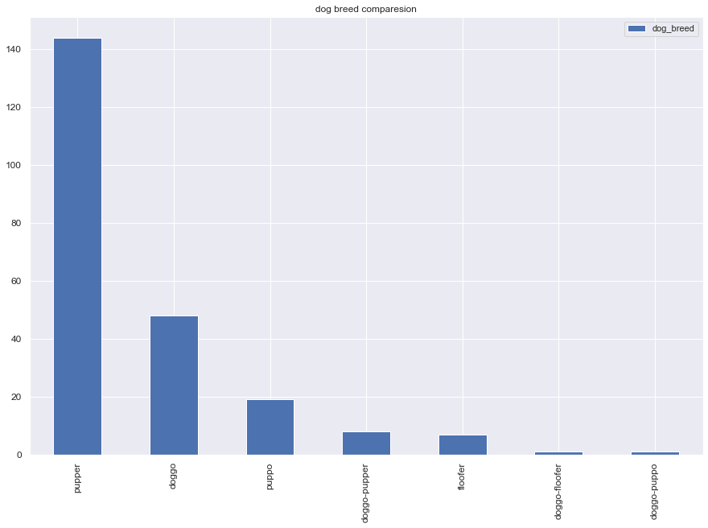

* **as the above chart shows, pupper has the majority of available data.**

**# show the comparison between the four types by bar plot by the average rate**

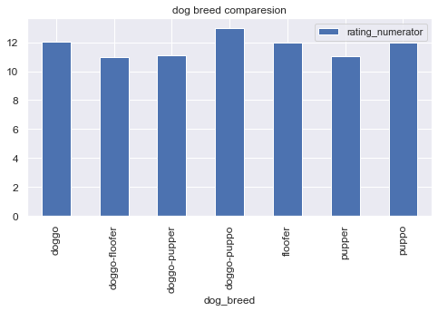

* **There is no apparent influence on the type of the dog that influences the rating process**

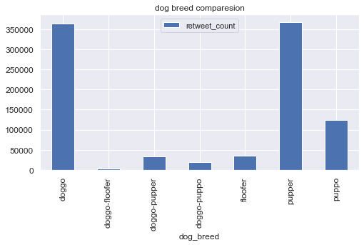

* **show a comparison between the four types by retweet numbers for every type, this chart presents the summation of tweets**

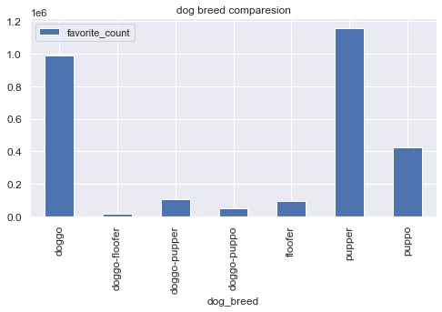

* **show a comparison between the four types by retweet numbers for every type, this chart presents the summation of favorite count**
* **show a comparison between the four types by retweet numbers for every type, this chart presents the summation of tweets, and it demonstrate that (doggo and pupper) have the most interest of fans as those have the most numbers of retweets, also the most numbers of likes. then it comes after them puppo.**

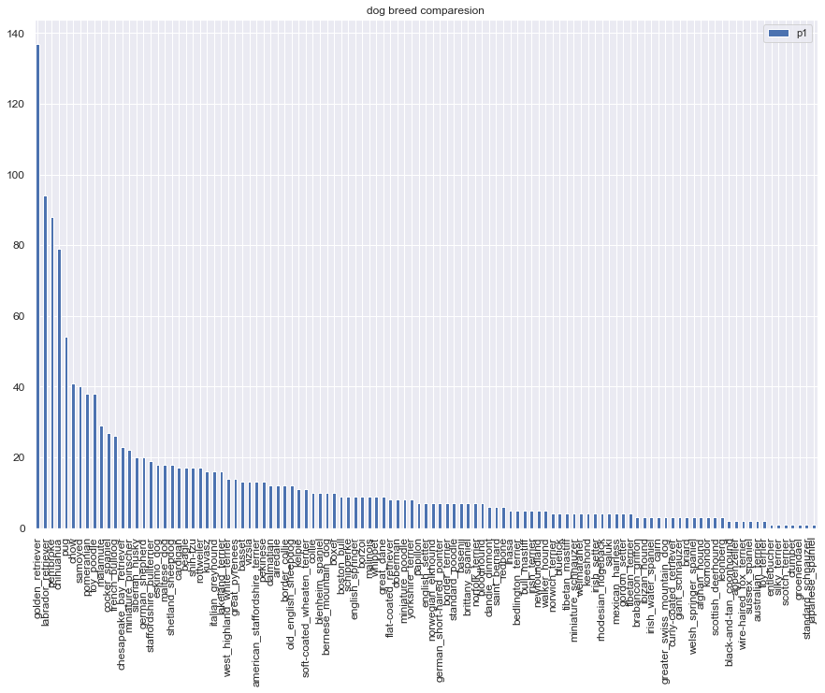

* **This chart presents the numbers of all kinds of dogs.**

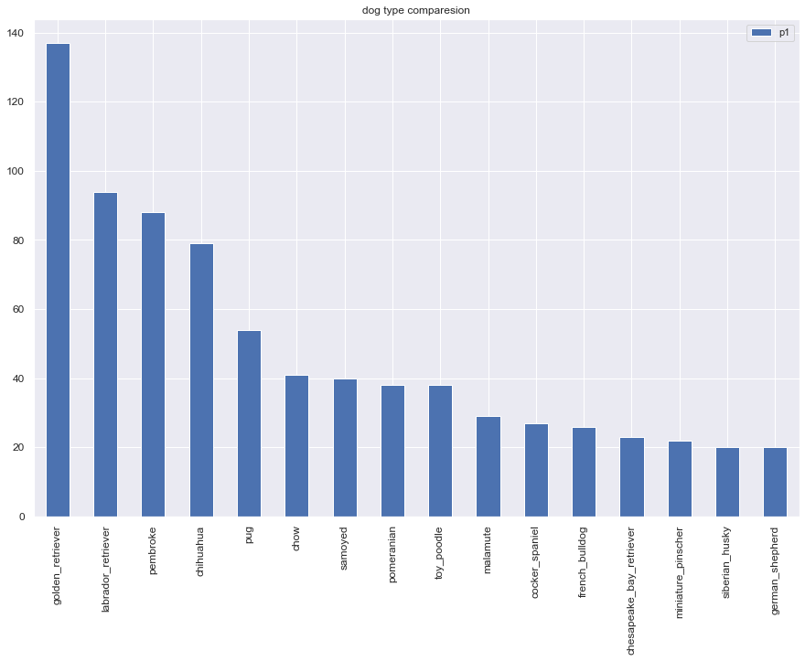

* **the most frequent dogs have been repeated**

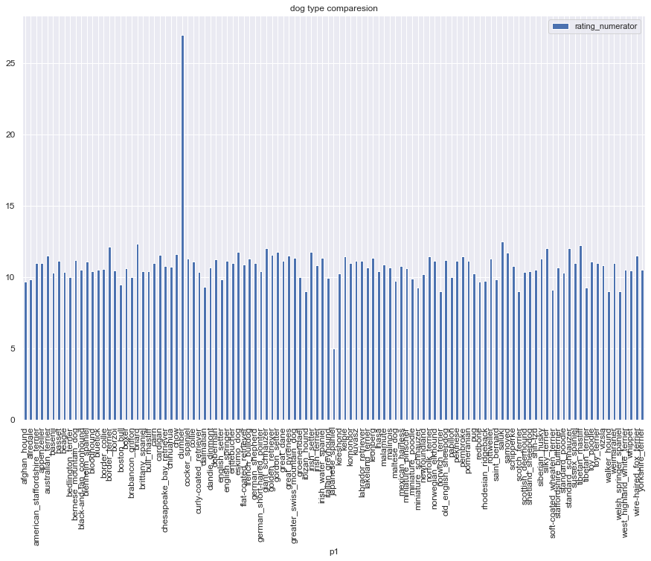

**• This chart proves that there is no influence of the kind of dog on the valuation of voters, as most of the rates are close**

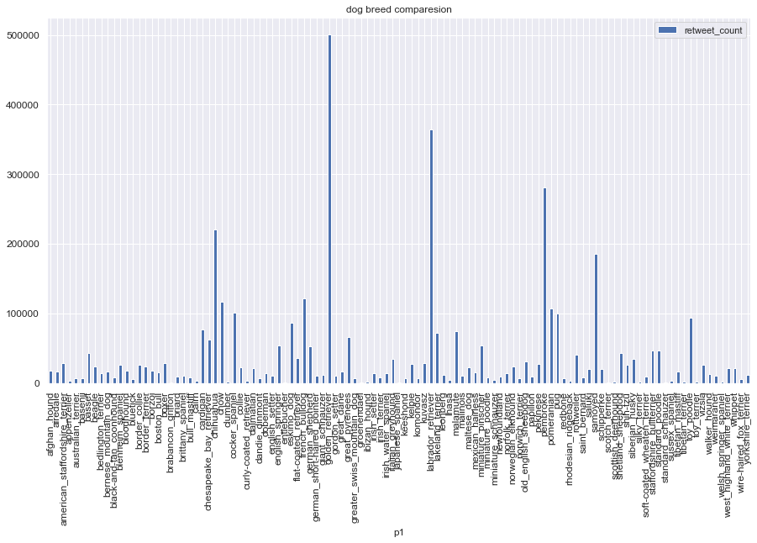

* **The chart above shows all retweets counts for all kinds**

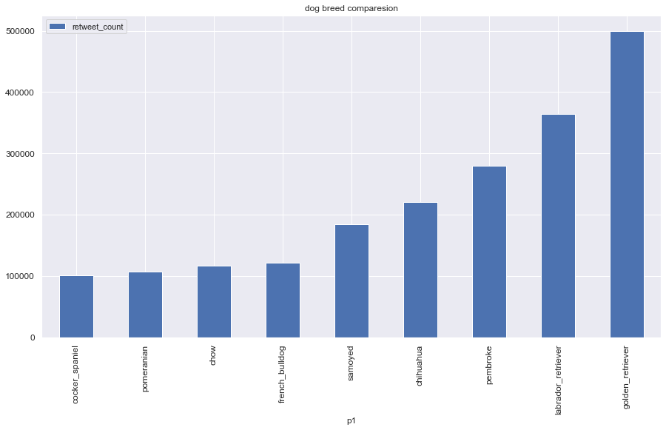

* **The chart above shows top 10 kinds of dogs have collected retweet**

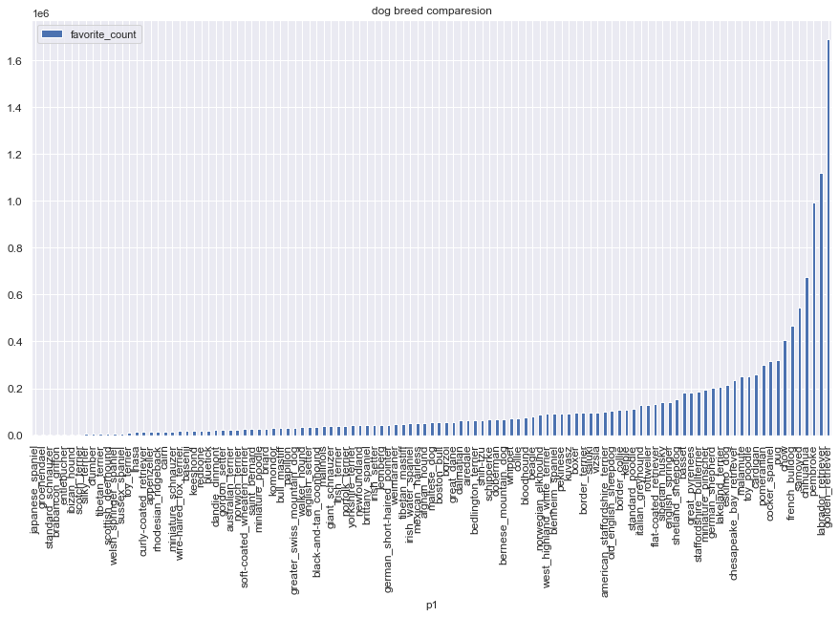

* **The chart above shows all favorite counts for all kinds.**

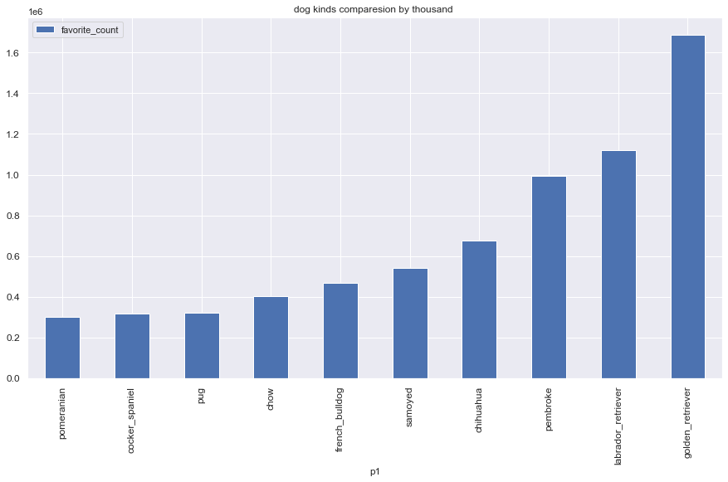

* **The chart above shows top 10 kinds of dogs have collected like.**
* **The previous two charts prove that there are types of dogs that are highly popular much more than others. And the most popular types of dogs definitely must be one of those [ golden_retriever , labrador_retriever , pembroke , chihuahua , Samoyed , french_bulldog , chow , pug , cocker_spaniel , Pomeranian , cardigan ]**